

**20% DISCOUNTED WINTER RATES – 01 April 2019 to 31st September 2019**

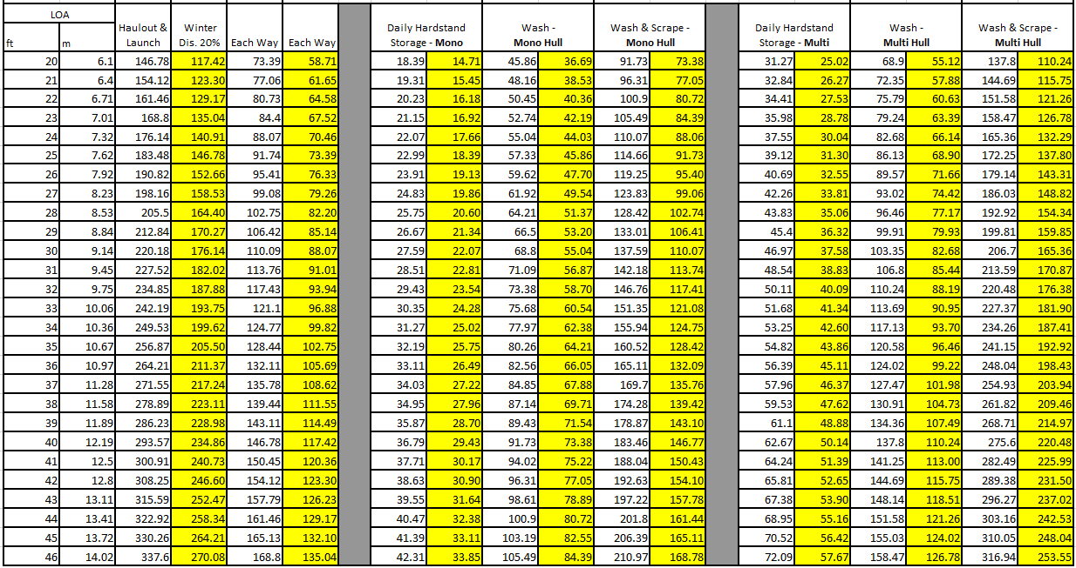

**Outside Dinghy Stands**

$150.00 annually only

Standard Wash -

Standard Wash -

Power Wash -

Power Wash -

**Secure Dinghy Lockers**

$400.00 annually only

**Third Party Liability Insurance Cover Rates**

1-15 days – $115.00

Full month – $230.00

**Labour & Equipment Standby Rates**

$100/hr – Tractor, equipment and operator

$75/hr – additional operator if required

$140/hr – Travel lift including operator

$165/hr – Hiab including operator

**Casual Car and Trailer Parking at The Landing** – $2/hr – Pay & Display machines (on-site)

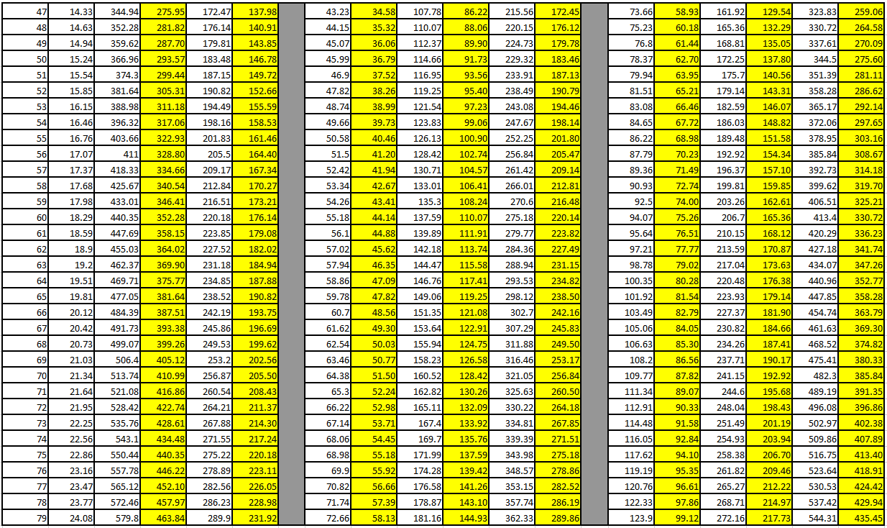

Standard Wash -

Standard Wash -

**Casual Car and Trailer Parking at The Landing** – $2/hr – Pay & Display machines (on-site)